Concepts-

Option 1-Bluetooth HC-05 with breadboard, arduino and buzzer

Option 2(We are using)- Nodemcu ESP8266 wifi module, blynk app,

piezo buzzer, jumper cables

**Concept used-**

Life will be easy for those who are visually impaired when they can easily navigate to their required drawers in their kitchen.

Our android application is totally hustle free, anyone can use it. When smart modular kitchen will be set up, our app will be fed with the information of what item is stored in what module. Any person can just say name of required item and module containing that item will start beeping which can be easily navigated by visually challenged people.

**Items-**

1. **Applications**- Android application will be using google assistant and an extra application know as BLYNK which is used to notify to hardware that which buzzer we want to beap.

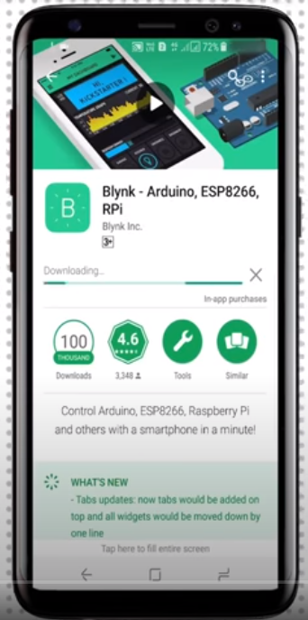 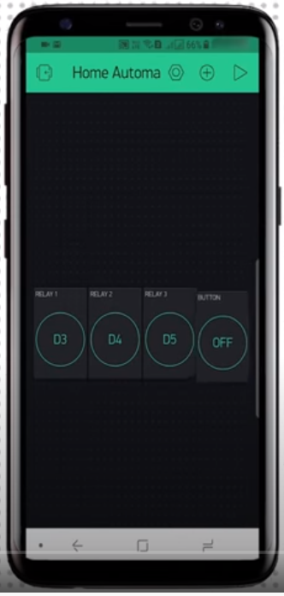 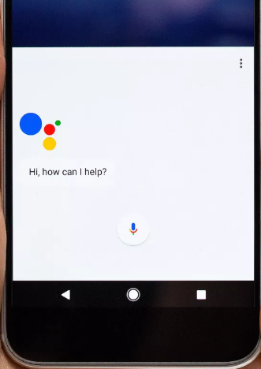

1. BLYNK- Blynk is a new platform that allows you to quickly build interfaces for controlling and monitoring your hardware projects from your iOS and Android device. After downloading the Blynk app, you can create a project dashboard and arrange buttons, sliders, graphs, and other widgets onto the screen. NODE MCU wifi module is controller using Blynk.
2. Google Assistant- Google Assistant is Google's voice assistant. When it launched, Google Assistant was an extension of Google Now, designed to be personal while expanding on Google's existing "OK Google" voice controls. It is used to convert voice into text and sends information to BLYNK app using IFTTT.
3. **Hardware requirements-**
4. **Jumper wires and normal cable wires-**

Jump wire (also known as jumper wire, or jumper) is an electrical wire, or group of them in a cable, with a connector or pin at each end (or sometimes without them – simply "tinned"), which is normally used to interconnect the components of a breadboard or other prototype or test circuit, internally or with other equipment or components, without soldering.

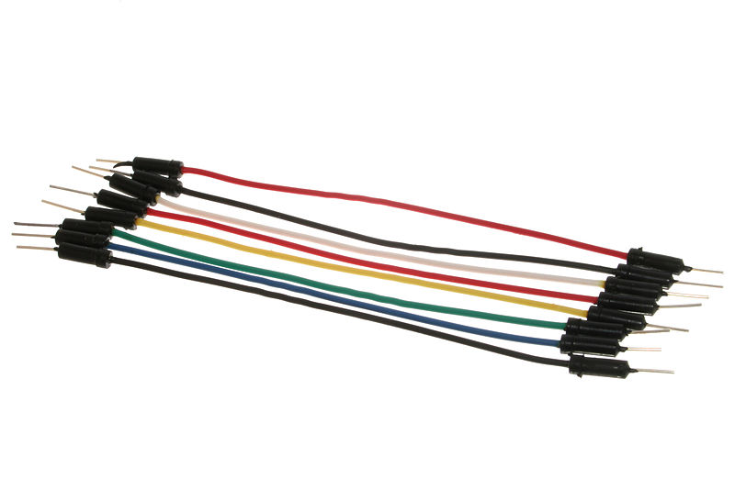 

1. **Piezo Buzzer-**

Piezo buzzers are simple devices that can generate basic beeps and tones.  They work by using a piezo crystal, a special material that changes shape when voltage is applied to it.  If the crystal pushes against a diaphragm, like a tiny speaker cone, it can generate a pressure wave which the human ear picks up as sound.  Simple change the frequency of the voltage sent to the piezo and it will start generating sounds by changing shape very quickly!

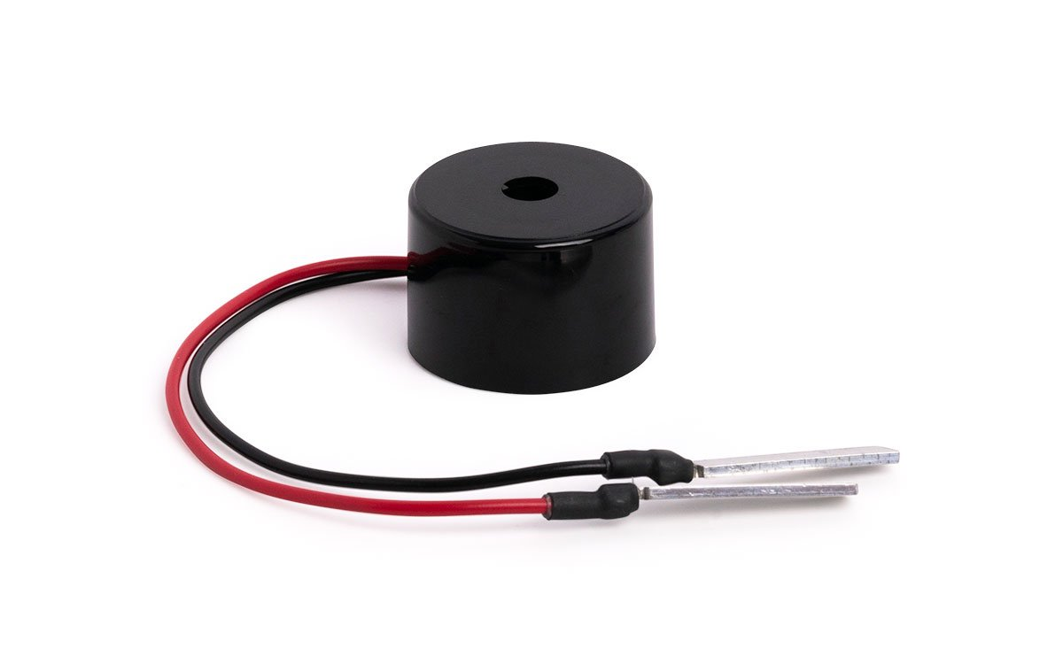 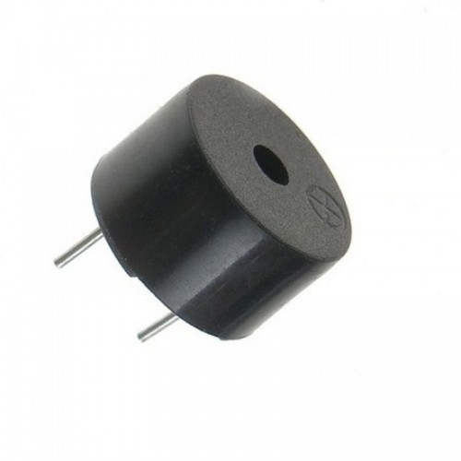

1. **Nodemcu ESP8266 wifi module-**

NodeMCU is a low-cost open source IoT platform. It initially included firmware which runs on the ESP8266 Wi-Fi SoC from Espressif Systems, and hardware which was based on the ESP-12 module. It can be connected to various devices and created wifi spot and those devices can be controller using apps like blynk and using wifi of android mobile phone.

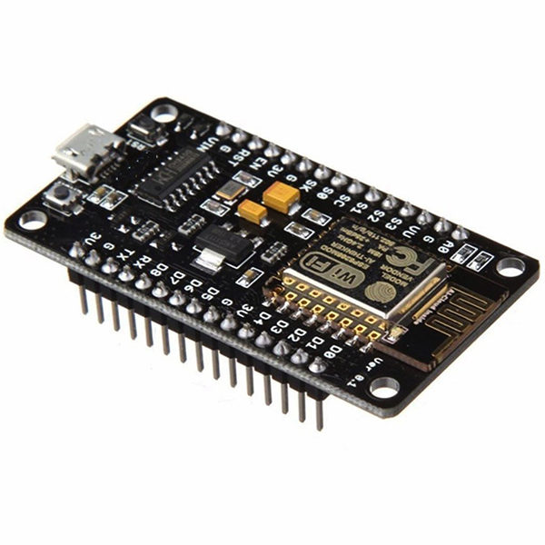 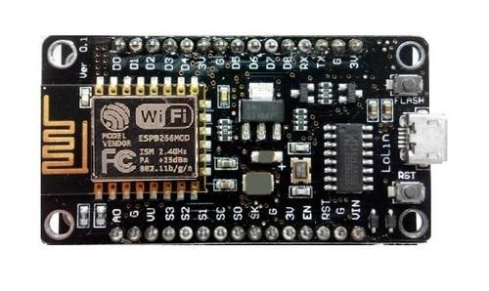

1. **Relay Module-**

The relay module is a separate hardware device used for remote device switching. With it you can remotely control devices over a network or the Internet. Devices can be remotely powered on or off with commands coming from ClockWatch Enterprise delivered over a local or wide area network.  You can control computers, peripherals or other powered devices from across the office or across the world.

The Relay module can be used to sense external On/Off conditions and to control a variety of external devices. The PC interface connection is made through the serial port.

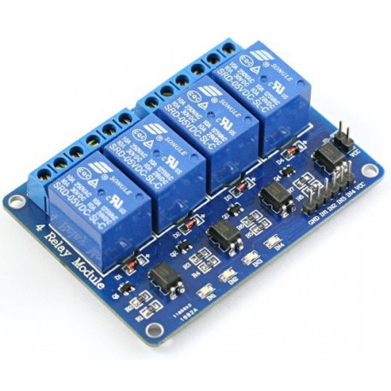 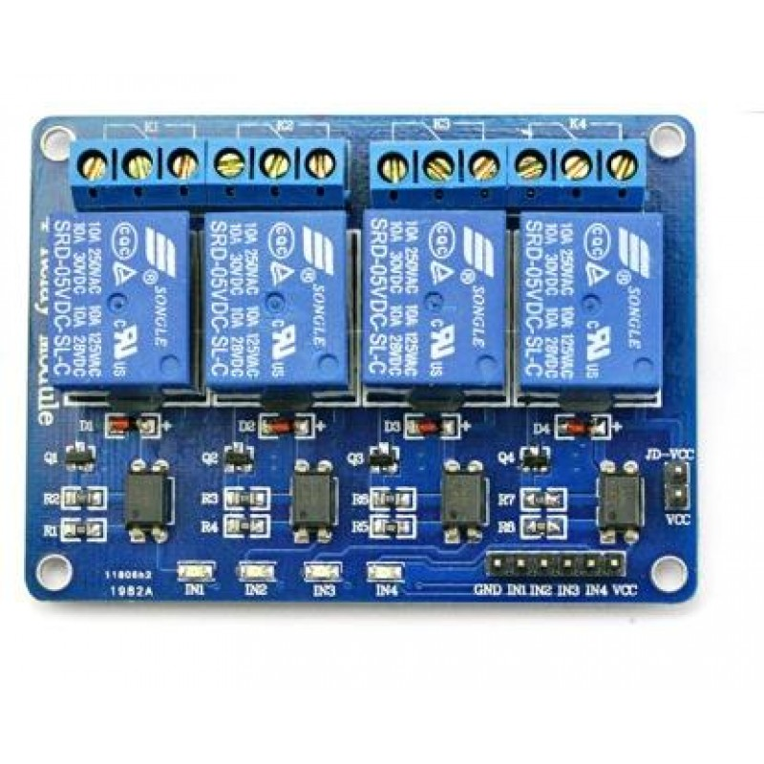

1. **Power supply-**

You have 3 possibilities for a power supply of the NodeMCU:

Operate the NodeMCU on the 3.3V input with 2.5V to 3.6V

Operate the NodeMCU on the VIN input pin with a voltage between 7V and 12V

Use a USB cable with 5V. A diode prevents current from the 5V input to the USB connection flows.

The built-in voltage regulator has a maximum power reserve of 300mA for external expansions at 5V input voltage.

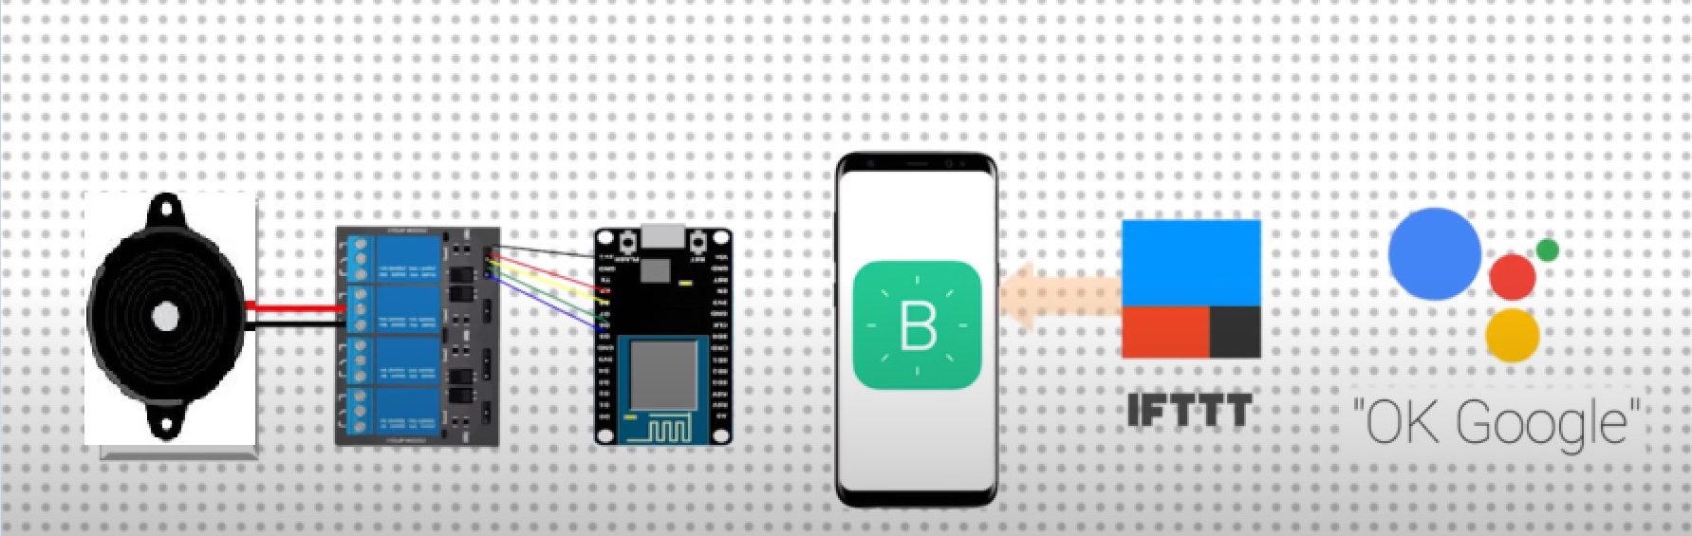

1. **IFTT**- IFTTT is the free way to get all your apps and devices talking to each other. If This Then That, also known as IFTTT, is a freeware web-based service that creates chains of simple conditional statements, called applets. An applet is triggered by changes that occur within other web services such as Gmail, Facebook, Telegram, Instagram, or Pinterest.